Pöttinger ROW CROP ASSIST:
Row crop cultivator configuration made easy
With its machines and digital solutions, the arable farming specialist Pöttinger is helping to make crop care work easier and even more precise. The new online application ROW CROP ASSIST gives interactive support to get the optimum configuration of FLEXCARE row crop cultivators. First, it requests information on the planting process and the tractor that will be used for the crop care work. The application then shows the optimum row crop cultivator configuration in a way that is clear and accessible to everyone.

Proven technology
Pöttinger has already successfully implemented the TRAMLINE ASSIST application for an optimum tramline system in arable farming. For harvesting grassland, HAYTOOL ASSIST makes it quick and easy to find the right tedder to match different mowers. Building on this success, Pöttinger is now launching ROW CROP ASSIST to optimise the set-up of mechanical crop care machines.
The objective of all the Pöttinger ASSIST applications is to optimise farming processes using intuitive on-screen visualisation and outputting notification messages with recommendations. That's how complex knowledge is tailored to specific use cases and displayed in a way that makes it easy to use.

FLEXCARE is as flexible as your farm business
Even the basic version of the FLEXCARE row crop cultivator from Pöttinger is unmatched in its ability to adapt to the needs of all crop types, the crop row widths, and the site-specific conditions. The hoe elements and weeding tools can be adapted to different processing scenarios in just a few steps.

Because climatic, social and political conditions are continuously changing, there is increasing demand to rethink existing arable farming strategies. The FLEXCARE row crop cultivator optimally prepares farmers and contractors for the future. The unbeatable flexibility of the row crop cultivator allows the farm to try out new crops and new planting systems without cost-intensive new purchases. This significantly lowers the barrier to start hoeing oil seed rape, field beans and cereals. In addition, it can be used for contract work and by machinery rings to increase machine utilisation.

The ROW CROP ASSIST applications provides support before and after buying a row crop cultivator to configure the machine in the best way possible depending on the seed drill and crop care technology used.

Get the best working results
The best working results depend on perfectly matched processes that minimise losses and make the best possible use of synergies. As an arable farming specialist, Pöttinger is also an expert in agronomic production systems. Maximum precision during the hoeing process is the key to the highest possible success in mechanical weed control. This can only be achieved by taking into account the previous sowing step.

The new ROW CROP ASSIST is available on the Pöttinger homepage - www.poettinger.at - under the menu item Digital agricultural technology from mid-July 2024.

Photo preview:
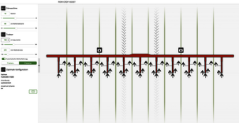 | 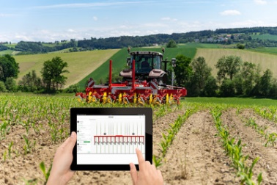
ROW CROP ASSIST helps find the best machine settings | CROP ASSIST, FLEXCARE
https://www.poettinger.at/de_at/newsroom/pressebild/143612 | https://www.poettinger.at/de_at/newsroom/pressebild/144023
More printer-optimised photos: http://www.poettinger.at/presse

